Learning Journal Unit 3

Godfrey Ouma
University of the People
MATH 1280: Introduction to Statistics
Esther Pearson
28 September 22, 2023

Learning Journal Unit 3
We are given a table with data of 67 members of the US Senate in June 2012 and their affiliated political party and when they are up for reelection.
Up for re-election: | Democratic Party | Republican Party | Other | Total
Nov-14 | 20 | 13 | 0 | 33
Nov-16 | 10 | 24 | 0 | 34
Total | 30 | 37 | 0 | 67

- What is the probability that a randomly selected senator is up for reelection in November 2016?
$$Probability = \frac{Number of senators up for reelection in November 2016 }{Total number of senators}=\frac{34}{67}≈0.5075$$
- What is the probability that a randomly selected senator is a Republican or is up for reelection in November 2014?
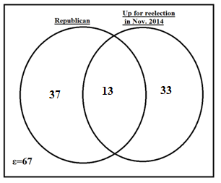
$P\left(R\right)=\frac{37}{67}$
$P\left(E\right)=\frac{33}{67}$
$P\left(R\right)nP\left(E\right)=\frac{13}{67}$
$P\left(R\right) or P\left(E\right)=P\left(R\right)+P\left(E\right)-\left\{P\left(R\right)nP(E)\right\}$
$$Probability =\left(\frac{37}{67}+\frac{33}{67} \right)-\frac{13}{67}=\frac{57}{67} ≈ 0.8507$$
- Suppose that a member of the US Senate is randomly selected. What is the probability that the senator is up for reelection in November 2014, knowing that this senator is a Republican?
$Probability =\frac{\left(Number of senators up for reelection in November 2014 who are Republicans\right)}{\left(Total number of senators up for reelection in November 2014\right)}$
$Probability =\frac{13}{37}≈0.3939$

